**7 Step Guide to LSCP Training**

1. **LSCP Website**

All our training information including details of each course, dates of future courses, links to resources and how to book on courses is available on the LSCP Website - [Click here](https://liverpoolscb.org.uk/lscb/training/multi-agency-training-and-workforce-development)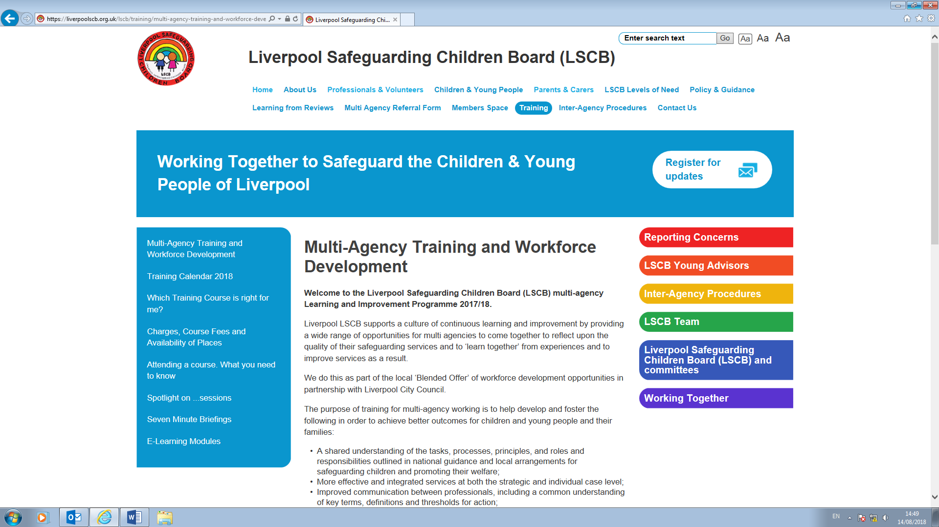

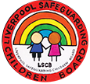

**3. Booking your place on a course**

Search for LSCP courses under the Multi-Agency section. All LSCP Courses have the prefix LSCP. Select the course you would like to attend and complete the booking form with your details.

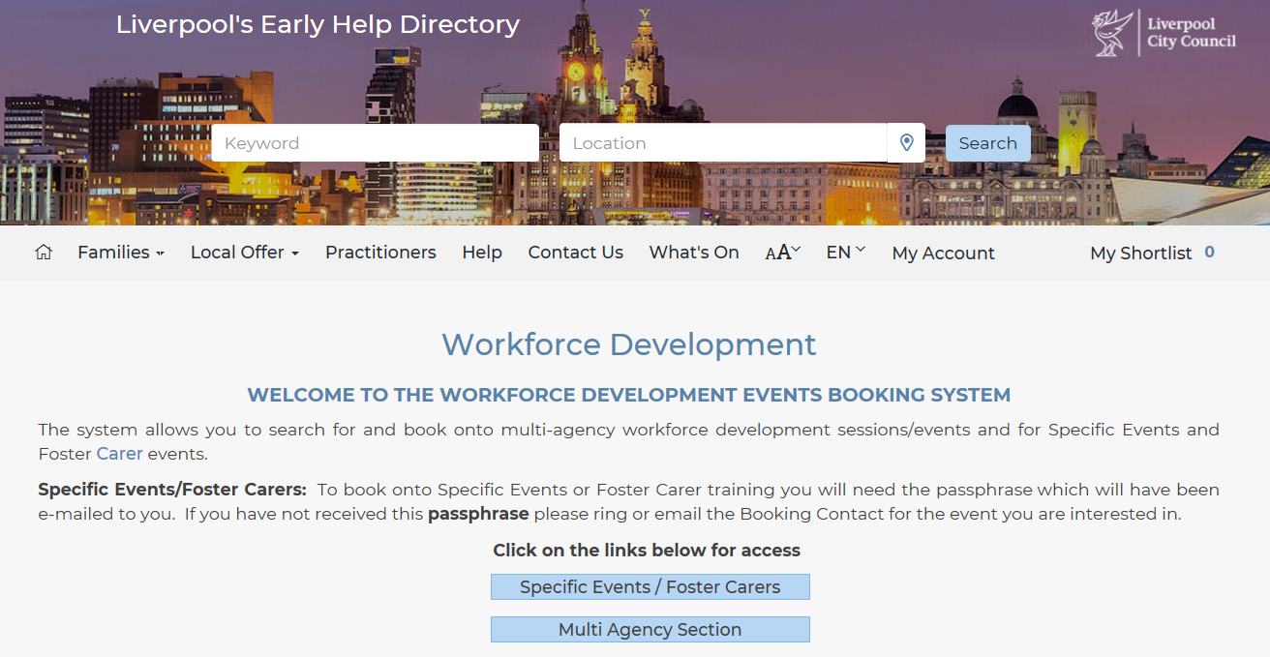

If you have not previously registered follow the on-line instructions.

Then you can complete the booking form with your details

**For further support and guidance using the Early Help Directory please click on the link to access EHD User Guides** [Click Here](http://fsd.liverpool.gov.uk/kb5/liverpool/fsd/advice.page?id=vv0XhNZByn0)

**7. Contact us**

Further dates are being added throughout the year, so please keep an eye on both the Early Help Directory and LSCP Website for new training dates and news

Email: [jane.mchale@liverpool.gov.uk](mailto:jane.mchale@liverpool.gov.uk)

Tel: 0151 233 0510

**4. What if I can’t find the course I’m looking for?**

If the event you are looking for is not showing up, this means it is fully booked.

By un-ticking the box when searching you will be able to see all the courses available including those that are fully booked.

**Please note**: people cancel places which then will become available on the system. We recommend you check the Early Help Directory regularly to see if places are available.

**6. Cancellation & charging policy**

The LSCP has a cancellation and charging policy for all training, please see details on our website - [Click here](https://liverpoolscb.org.uk/lscb/training/charges-course-fees-and-availability-of-places)

**If you are unable to attend any training please cancel your place using the Early Help Directory, as this makes your place available for others**

**5. Training Dates**

**Please note:** courses may change, all dates are correct at time of publication, please refer back to the Early Help Directory for the latest information and training dates

NB: The LSCP 2 Day Working Together Course can be found within the Specific Events Section, you will need the Passphrase to book this course and your line manager will be able to provide this.

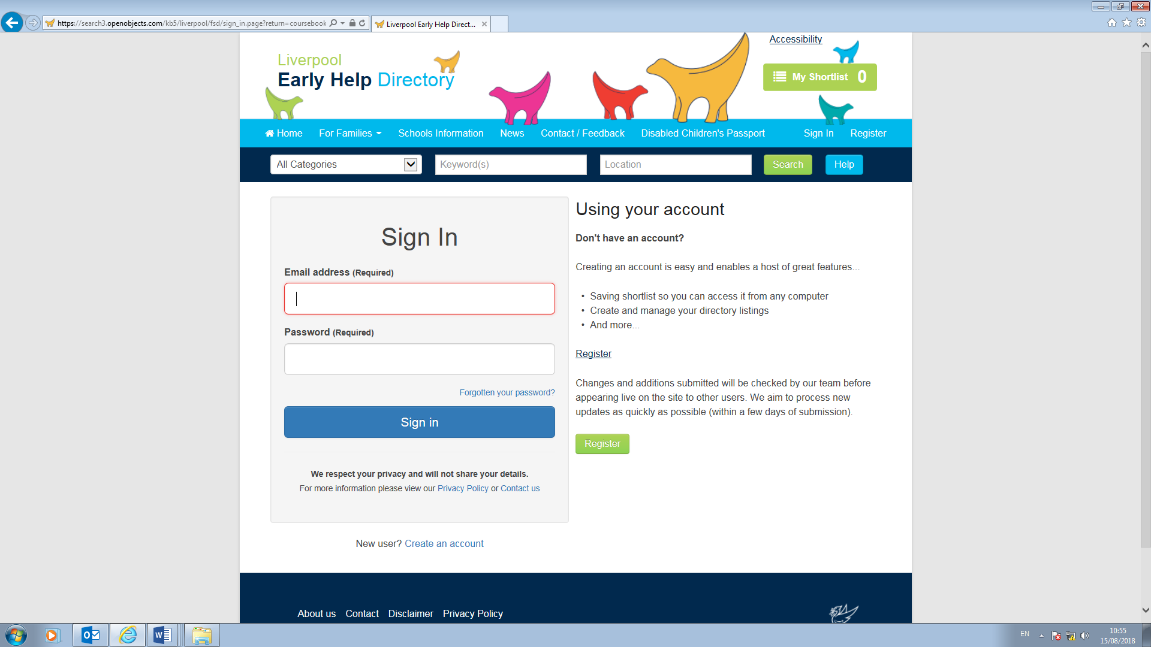

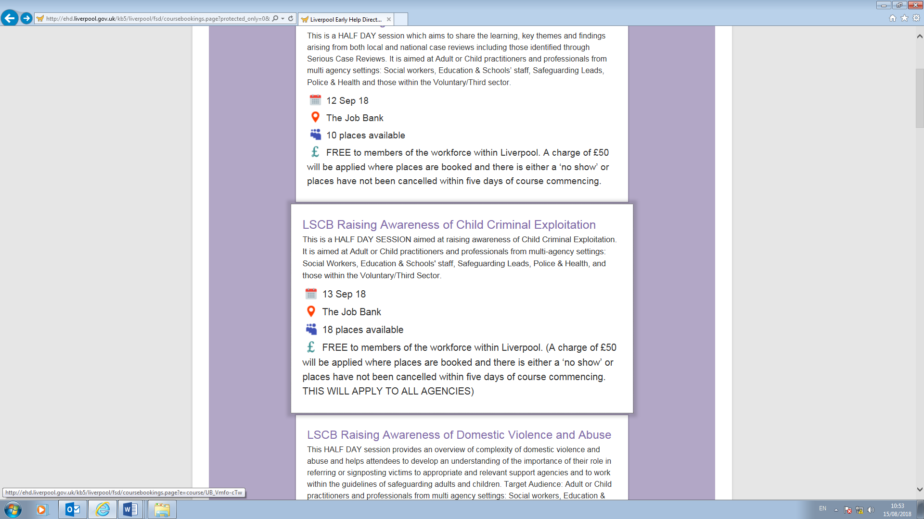

NB: If this is the first time you have accessed the system you will be prompted to register

**2. How to book onto a LSCP Course**

To book on a training course please log onto our

On-line booking system via the Early Help Directory - [Click here](http://ehd.liverpool.gov.uk/kb5/liverpool/fsd/home.page) - full instructions are detailed below

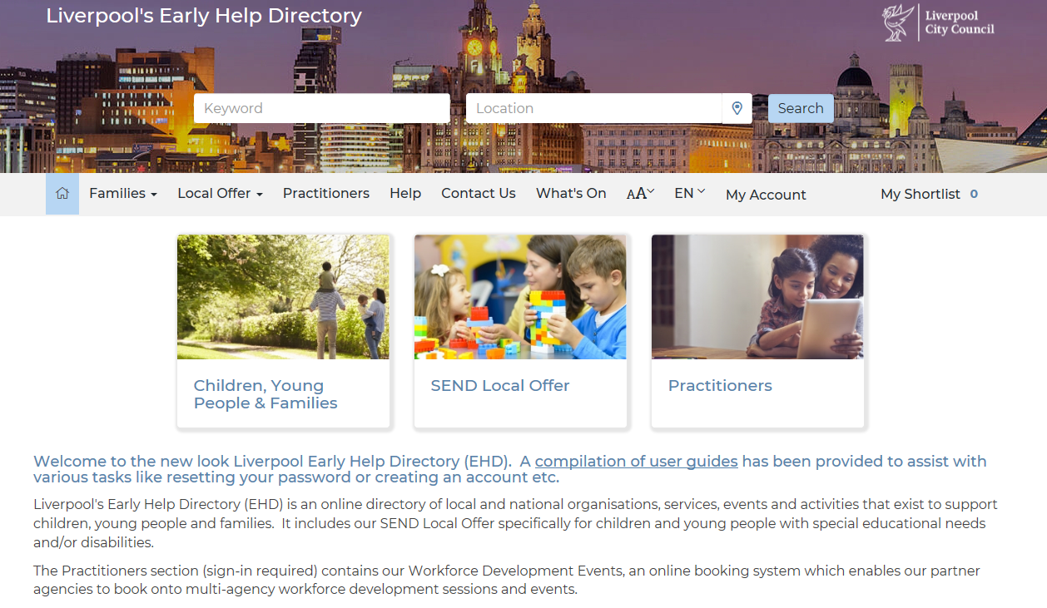

You then need to click onto the Practitioner Section and select Workforce Development

At this point you are asked to sign in.



All LSCP Courses have the prefix LSCP within this section.

If booking onto the 2-day Working Together Course, you will need to search for dates using the Specific Events/Foster Carers tab and you will be prompted to include the passphrase for this course when booking.